**RADIO NETWORK CONTROLLER**

**by**

**EMMANUEL WILLIAM Y.**

**st/cs/nd/19/341**

**BEING A SEMINAR PAPER**

**PRESENTED TO THE DEPARTMENT OF COMPUTER SCIENCE, SCHOOL OF SCIENCE AND TECHNOLOGY,**

**FEDERAL POLYTECHNIC MUBI, ADAMAWA STATE, NIGERIA**

**DECEMBER, 2021**

**Abstract**

*A Radio Network Controller (RNC) provides the interface between the wireless devices communicating through Node B transceivers and the network edge. This includes controlling and managing the radio transceivers in the Node B equipment, as well as management tasks like soft handoff. The RNC performs tasks in a 3G wireless network analogous to those of the Base Station Controller (BSC) in a 2G or 2.5G network. It interfaces with GPRS Service Nodes (SGSNs) and Gateways (GGSNs) to mediate with the network service providers. A radio network controller manages hundreds of Node B transceiver stations while switching and provisioning services off the Mobile Switching Center and 3G data network interfaces. The connection from the RNC to a Node B is called the User Plane Interface Layer and it uses T1/E1 transport to the RNC.*

**INTRODUCTION**

Mobility, privacy and immediacy offered by wireless access commonly create new opportunities for Internet business, and mobile networks are becoming a platform that provides leading-edge Internet services. Through integration of the Internet and the third generation (3G) wireless communication, next generation telecommunications networks will provide global information access for mobile users (Saitoh and Sonobe, 2010). 3GPP proposed the *Universal Mobile Telecommunications System* (UMTS) all-IP architecture to integrate the IP and wireless technologies, which has evolved from the GSM, *General Packet Radio Service* (GPRS).

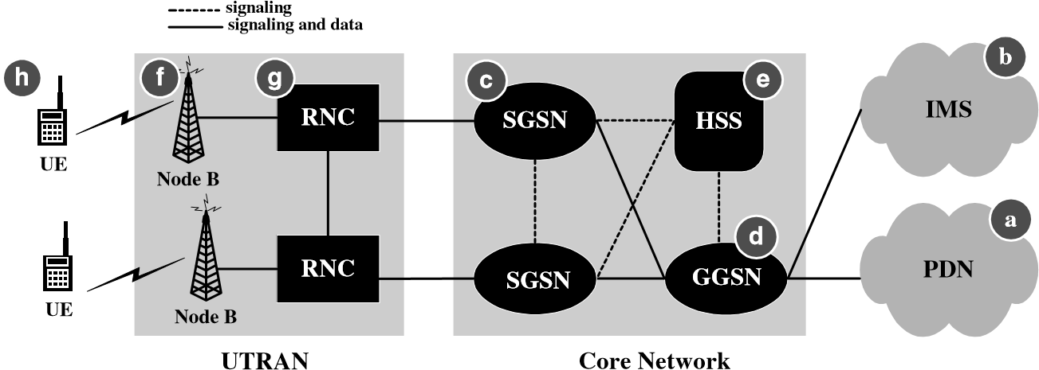

Figure 1: The UMTS All-IP Network Architecture (Saitoh and SOnobe, 2010).

The UMTS Radio Access Network, UTRAN, or Radio Network Subsystem, RNS comprises two main components:

1. ***Radio Network Controller, RNC:***   This element of the UTRAN / radio network subsystem controls the Node Bs that are connected to it, i.e. the radio resources in its domain.. The RNC undertakes the radio resource management and some of the mobility management functions, although not all. It is also the point at which the data encryption / decryption is performed to protect the user data from eavesdropping.
2. ***Node B:***   Node B is the term used within UMTS to denote the base station transceiver. This part of the UTRAN contains the transmitter and receiver to communicate with the UEs within the cell. It participates with the RNC in the resource management. NodeB is the 3GPP term for base station, and often the terms are used interchangeably.

In order to facilitate effective handover between Node Bs under the control of different RNCs, the RNC not only communicates with the Core Network, but also with neighbouring RNCs.

A Radio Network Controller is a major component in the UMTS Radio Access Network, controlling several Node B’s connected to it. The RNC is also responsible for a couple of mobility management functions. Serving as a center of encryption without which the transfer of user data from the mobile would be impossible. The RNC allocates the resources needed in the Radio Network System. The management of radio resources is a function of the RNC. When you set up a Mobile Originated Call (MOC), the connection is going to be initiated by the User Equipment. The User Equipment is notified after the radio network controller has made the required resources available (Kelly, 2017).

**Radio Network Controller** (**RNC**) is a governing element in the [UMTS](https://en.wikipedia.org/wiki/UMTS) radio access network ([UTRAN](https://en.wikipedia.org/wiki/UTRAN)) and is responsible for controlling the [Node Bs](https://en.wikipedia.org/wiki/Node_B) that are connected to it. The RNC carries out [radio resource management](https://en.wikipedia.org/wiki/Radio_resource_management), some of the [mobility management](https://en.wikipedia.org/wiki/Mobility_management) functions and is the point where encryption is done before user data is sent to and from the mobile. The RNC connects to the Circuit Switched Core Network through Media Gateway ([MGW](https://en.wikipedia.org/wiki/Media_gateway)) and to the [SGSN](https://en.wikipedia.org/wiki/SGSN) (Serving GPRS Support Node) in the [Packet Switched Core Network](https://en.wikipedia.org/wiki/Packet_Switched_Core_Network) (Lin and Pang, 2012).

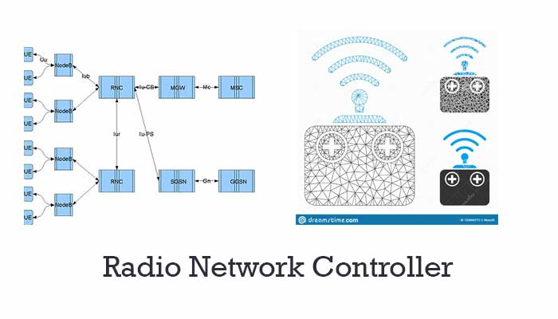

Figure 2: Radio Network Controller (Lin and Pang, 2012).

It also consists of Interfaces. These Interfaces makes the logical connection in the network. The Interface between the RNC and Circuit Switched core network is called Iu-CS. And the interface between the RNC and the packet-switched core network is called the Iu-PS. The Radio Network controller also includes other interfaces like IUB and Iur. The Iu interface carries the user information and controller information. The Iur interfaces are mainly used for the soft handover involving the 2 RNCs. The absence of these causes this Iur to become the hard handovers (Lin, Cheng & Agrawal, 2013).

In the 3gpp R4, all the interfaces in the UTRAN are implemented using only the ATM. The Iu interface only uses WCDMA Technology. The R5 and Ip bearers can be used over the Ethernet connection. All these Interfaces are carried by the SDH in an optical fiber. The E1 is carried over a copper wire. It can also be carried over by the microwave radio. The IMA Group is formed by the bundle of the E1s. All these Interfaces contains the logical connection in the network. We can multiplex several interfaces in the same transmission line.

**RADIO NETWORK CONTROLLER Interfaces**

The UMTS standards are structured in a way that the internal functionality of the different network elements is not defined. Instead, the interfaces between the network elements is defined and in this way, so too is the element functionality (Lin, Cheng & Angrawal, 2013).

There are several interfaces that are defined for the UTRAN elements:

1. ***Iu:***   The Iu interface connects the UTRAN to the core network.
2. ***Iub:***   The Iub connects the NodeB and the RNC within the UTRAN. Although when it was launched, a standardisation of the interface between the controller and base station in the UTRAN was revolutionary, the aim was to stimulate competition between suppliers, allowing opportunities like some manufacturers who might concentrate just on base stations rather than the controller and other network entities.
3. ***Iur:***   The Iur interface allows communication between different RNCs within the UTRAN. The open Iur interface enables capabilities like soft handover to occur as well as helping to stimulate competition between equipment manufacturers.

Having standardised interfaces within various areas of the network including the UTRAN allows network operators to select different network entities from different suppliers.

The logical connections between the network elements are known as interfaces. The interface between the RNC and the Circuit Switched Core Network (CS-CN) is called Iu-CS and between the RNC and the Packet Switched Core Network is called Iu-PS. Other interfaces include Iub (between the RNC and the Node B) and Iur (between RNCs in the same network). Iu interfaces carry user traffic (such as voice or data) as well as control information (see [§ Protocols](https://en.wikipedia.org/wiki/Radio_Network_Controller#Protocols)), and Iur interface is mainly needed for [soft handovers](https://en.wikipedia.org/wiki/Soft_handover) involving 2 RNCs though not required as the absence of Iur will cause these handovers to become [hard handovers](https://en.wikipedia.org/w/index.php?title=Hard_handovers&action=edit&redlink=1) (Holma and Toskala, 2014).

Until 3gpp R4, all the interfaces in the [UTRAN](https://en.wikipedia.org/wiki/UTRAN) are implemented using [ATM](https://en.wikipedia.org/wiki/Asynchronous_Transfer_Mode) only, except the [(air) interface](https://en.wikipedia.org/wiki/Universal_Mobile_Telecommunications_System#Air_interfaces) which uses [WCDMA](https://en.wikipedia.org/wiki/WCDMA) technology. Starting R5, [IP](https://en.wikipedia.org/wiki/Internet_Protocol) bearers can be used over [Ethernet](https://en.wikipedia.org/wiki/Ethernet) instead. Physically, these interfaces can be carried over [SDH](https://en.wikipedia.org/wiki/Synchronous_Digital_Hierarchy) over optical fiber, [E1](https://en.wikipedia.org/wiki/E-carrier) (sometimes referred to as [PDH](https://en.wikipedia.org/wiki/Plesiochronous_Digital_Hierarchy)) - over a copper wire or [microwave radio](https://en.wikipedia.org/wiki/Microwave_radio_relay). Several E1s can be bundled to form an [IMA](https://en.wikipedia.org/wiki/Inverse_Multiplexing_for_ATM) Group. Since the interfaces are *logical*, many interfaces can be multiplexed onto the same transmission line. The actual implementation depends on the [network topology](https://en.wikipedia.org/wiki/Network_topology); examples are chain, distant star, mesh and loop configurations.

Radio network optimization is carried out in order to improve the network performance with the existing resources. The main purpose is to increase the utilization of the network resources, solve the existing and potential problems on the network and identify the probable solutions for future network planning.

Through Radio Network Optimization, the service quality and resources usage of the network are greatly improved and the balance among coverage, capacity and quality is achieved (Kelly, 2017).

In general, the following steps are followed during the Radio Network Optimization:

1. Data Collection and verification
2. Data analysis
3. Parameter and hardware adjustment
4. Optimization result confirmation and reporting.

Due to the mobility of subscribers and complexity of the radio wave propagation, most of network problems are caused by increasing subscribers and the changing environment. Radio Network Optimization is a continuous process that is required as the network evolves.

### Benefits of Radio Network Controller System

According to Bos and Leroy (2011), the functions of the RNC are similar to that of the Base Station Controller in 2G systems. The prime functionality of the RNC is to control the number of Node B’s attached to it. However, the RNC is also responsible for several other operations in the RNS. Here are some of the benefits of the RNC System;

### Radio Resource Management

The RNC provides the radio resources to the User Equipment unit and forwards that management to Node B and finally to the user. The end-user gets easy access to Radio Resources through the management process of the RNC.

### Employing Protocols for UMTS Network

The RNC is also responsible for employing some important protocols for the UMTS network. These protocols include;

1. **Radio Resource Control (RRC):** The RRC is the unit that governs connection. The connection setup, establishment, and release of such connections are controlled and implemented by the RNC. The RNC allocates the radio resources to various points of functions where they are needed in a Radio Network System. Thereby facilitating the setup of these functions.
2. **Radio Access Bearer (RAB):** The RAB is responsible for transporting signals across the network, which improves the Quality of Services that the users will experience. While the RRC is responsible for the control of connections and functions, the RAB, however, conveys the required information to users.

### Administration Control

Admission control is a form of validation check that confirms that the resources provided to the User Equipment are adequate. The RNC ensures that users get the right amount of information they’ve requested while using wireless services.

### Implementation of IU Protocols

The RNC aids the connection of the RAN to the Core Network using the iu protocols. This RNC serves as an intermediary between the components of the RAN and the Core Network, as the RNC is connected to the Circuit Switch Domain and the Package Switch Domain.

### Drift-RNC

When a cell controlled by an external RNC creates a connection between the Service RNC (SRNC) and User Equipment, a DRNC exists. Generally, the DRNC functions as a switch that transfers information between the UE and the SRNC.

**CONCLUSION**

This seminar paper described the features of the radio network control system and its software and hardware technologies. Our RNC and MPE consist of various function units for realizing high scalability. Furthermore, each function unit in our RNC and MPE has a unique structure for achieving the required functionality so that all transactions are processed effectively and various high-quality services can be provided. Commercial service using IMT-2000 technology has already started, and the demands for services at much higher bit-rates and lower cost will only increase in the future.

**RECOMMENDATION**

The 5G is now specifying a new high-speed data communication technology called HSDPA (High Speed Data Packet Access) that will make it possible to transport downlink packet data at about 10 Mb/s in a specific channel shared by several users. In addition, the 3GPP is also investigating the introduction of IP technology into UTRAN with the aim of reducing network costs.

The new systems that could come from these efforts would be effective for future mobile communication systems, but they will require more advanced technology. Fujitsu will gradually introduce this technology into its own radio network control systems to provide various services with high quality and reliability and at lower cost.

**REFERENCES**

Bos, L., & Leroy, S. (2011). Toward an All-IP-based UMTS System Architecture. *International Journal of Electrical Electronics Engineering*, *15(1),* 36–45.

Fang, Y., & Chlamtac, I. (2019). Analysis and Mobility Modeling for PCS Networks. *Electrical Electronics Journal of Transactions on Communications*, *47(7),* 1062-1072.

Holma, H., & Toskala, A. (2014). *WCDMA for UMTS*. John Wiley & Sons, 2000.

Kelly, F. (2017). *Reversibility and Stochastic Networks*. John Wiley & Sons, New York.

Lin, Y. & Pang, H. (2012). AIIIP Approach for Third Generation Mobile Networks. *International Journal of Electrical Electronics Engineering,* 16(5), 8–19.

Lin, Y., Cheng, H., & Agrawal, P. (2013). Implementing Automatic Location Update for Follow-Me Database using VoIP and Bluetooth Technologies. *International Journal of Electrical Electronics Engineering,* 51(10), 1154–1168.

Martins, K. (2016). 3rd Generation Partnership Project; Technical Specification Group Radio Access Network; UTRAN Iu Interface RANAP Signaling for Release 1999. *International Journal of Computer Networks and Security, 25*(12), 45-78.

Saitoh, T. & Sonobe, T. (2010). Equipment for Radio Network System. *Journal of Information Technology Science, 51(1),* 45-50.